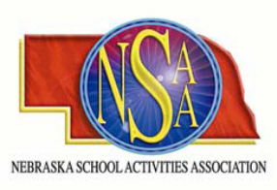
NSAA/MOA 3-PERSON CLINICS
Midwest Officials Association and Nebraska School Activities Association
is sponsoring a basketball officiating clinics at Omaha Sports Academy. Officials
should come prepared to officiate. Full uniform is required. Attendees will be divided into groups for each session. Each group will have court time and classroom time. We will make every effort to accommodate crews.
Sunday, November 22, 2009
Check In: 10:00am – 11:00am

Group 1 Group 2
10:15 Pre-Game 11:15 Pregame
11:00 Game 12:00 Game
12:00 Classroom / Discussion /Observe 1:00 Classroom/Discussion/Observe
1:00 Game 2:00 Game

$25.00 Before Nov 18
Preregistration is required.
Complete the registration form with all the necessary information and enclose payment of $25.00.
The fee is non-refundable. Return by November 18, 2009 SPACE IS LIMITED!

Name:__________________________________________________________

Address:________________________________________________________

City, State, Zip:___________________________________________________

Telephone #:_____________________________________________________

E-mail:__________________________________________________________

Crew Members also Attending:______________________________________

MAIL TO:
Midwest Officials Association
12504 Woolworth Ave.
Omaha Ne 68144

